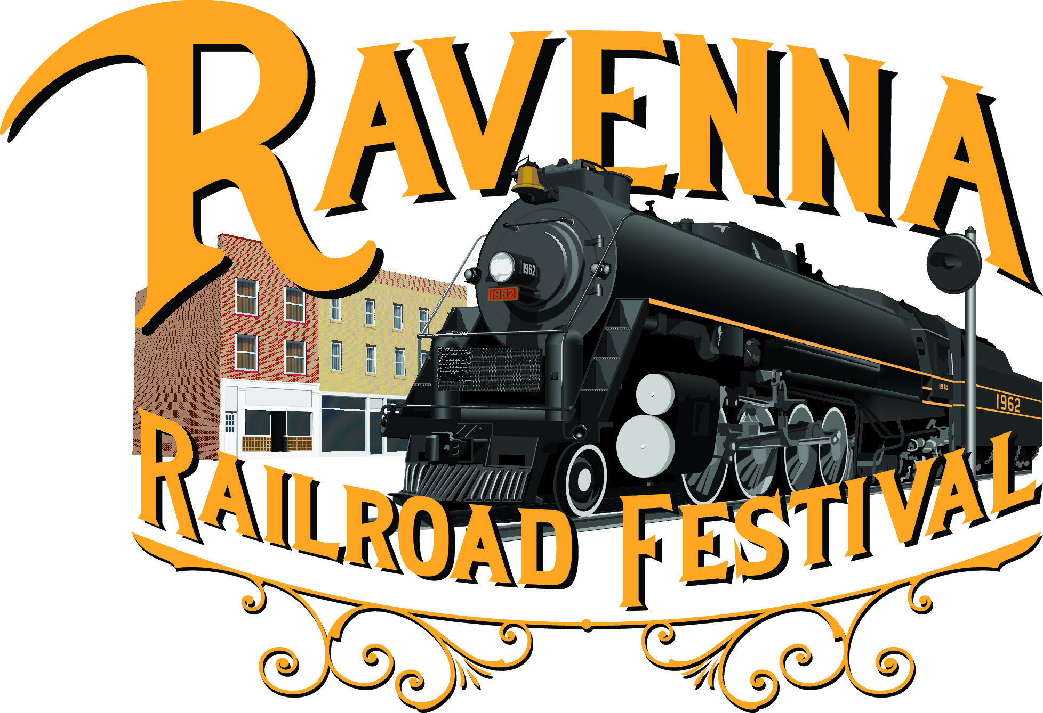
Ravenna Railroad Festival
Miss Railroad Festival Entry Form

Please select contestant age group:

Baby Miss (0-23 months) |  | Tiny Miss  (2-4 years)
Little Miss/Mister  (5-7) |  | Pre-Teen (8-12)
Teen (13-15) |  | Miss (16-21)

Preferred name: |  | Age:
Grade in school:
Hair color: |  | Eye Color:
Favorite color: |  | Favorite Food:

Person she looks up to:

Because:

Hobbies/Interests/Clubs:

Her goals are:

Three words that
best describe her are:

If you had one wish,
what would you wish for?

………………………………………………………………………………………………………
Contestant Information
Full Name |  | Date of Birth
Phone number |  | Parents’ Names
Mailing address:
Parent’s signature if
contestant is under the age of 18

